**Continuous Integration with Selenium in Jenkins**

As a DevOps engineer, you are required to perform continuous integration with Selenium and TestNG in Jenkins

Expected Deliverables: Console output from Jenkins dashboard

1. Installing selenium plugin on Jenkins

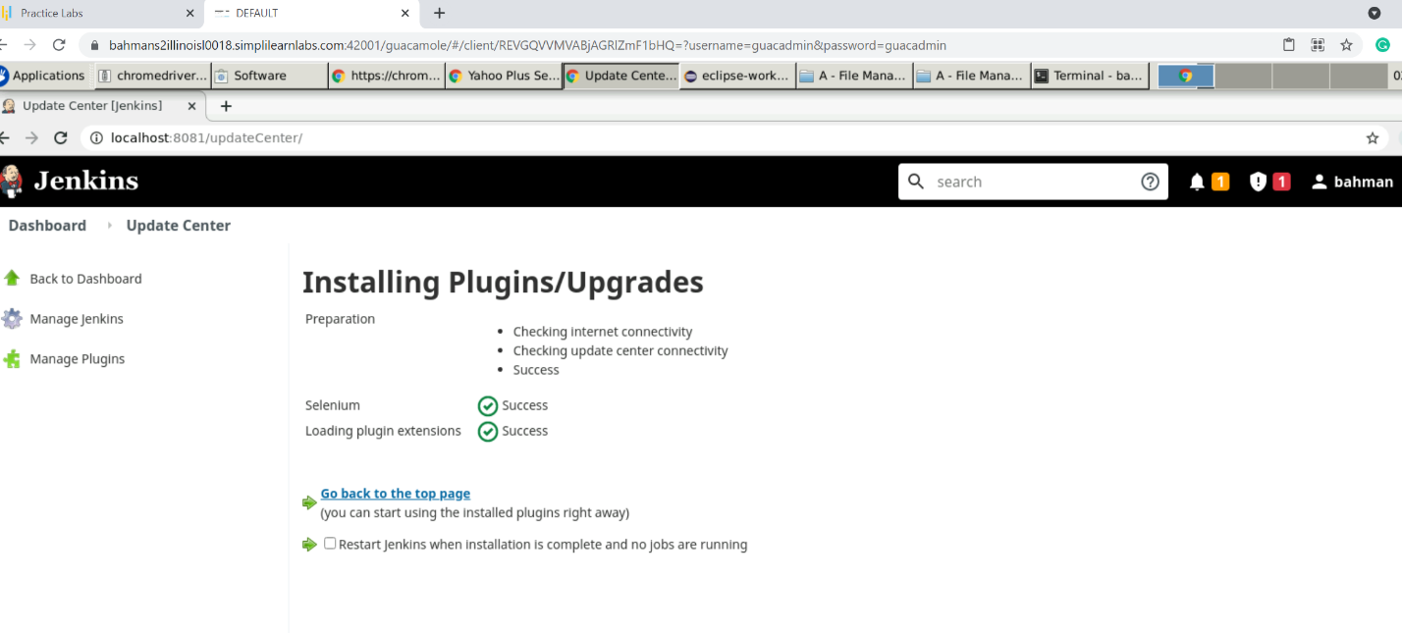

1. Installing Maven-Integration on Jenkins

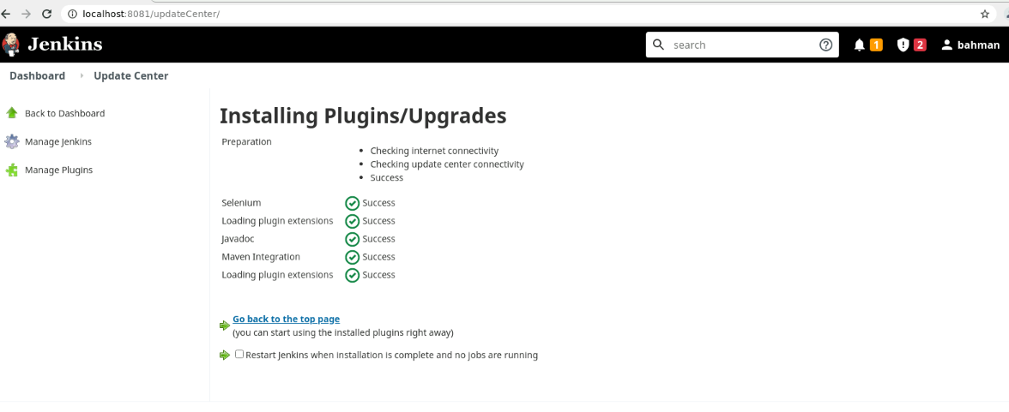

1. Create a Jenkins project using Maven

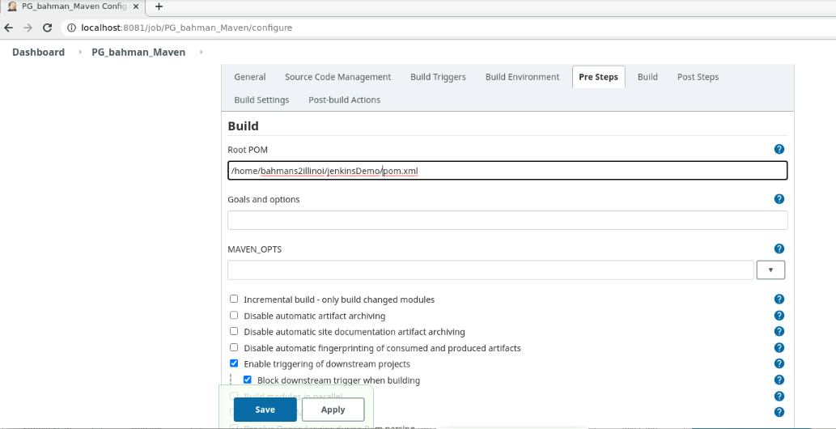

1. Run and Final console output of Jenkins

